***Appendix 1: Assignment submission cover sheet***

***ASSIGNMENT SUBMISSION COVER SHEET***

***Student Id:* CSE21-091**

***Student names:* KELEBOGILE MILDRED MALOPE**

***Student email:* CSE21-091@thuto.bac.ac.bw**

***Cohort:*  CSE GROUP 2**

***Assignment title:* IMPLEMENTATON OF SORTING & SEARCHING ALGORITHM**

***Date of submission:* 23/05/2022**

***Programme of Study*: COMPUTER SYSTEMS EGINEERNG**

***Year of Study*: YEAR 1**

***Intellectual property statement***

***By checking the box below, I certify that this assignment is my own work and is free from***

***plagiarism. I understand that the assignment may be checked for plagiarism by***

***electronic or other means and may be transferred and stored in a database for the***

***purposes of data-matching to help detect plagiarism. The assignment has not***

***previously been submitted for assessment in any other unit or to any other institution. I***

***have read and understood the Botswana Accountancy College plagiarism guidelines***

***policy.***

***☐ Agree Signature……K.MALOPE……………………………….***



***Date………………23/05.2022………………………….***

***IMPLEMENTATION OF THE SORTING AND SEARCHING ALGORITHM***

**Introduction: The idea of this project was to write a program that attempts to search, sort, read, write, count words in a file, randomly pick words from a readable File and compute runtime for the program. The program has been broken down into classes/block of codes which will then be called or implemented in the Graphical User Interface.**

***TEST CASES,CLASSES, GUI AND HOW THEY WORK :***

**1.READABLE FILE**

**The below picture shows a READABLE FILE. This is the readable file of which data is going to be retrieved from during file reading, counting, sorting, searching, conversion of words to array and writing.**

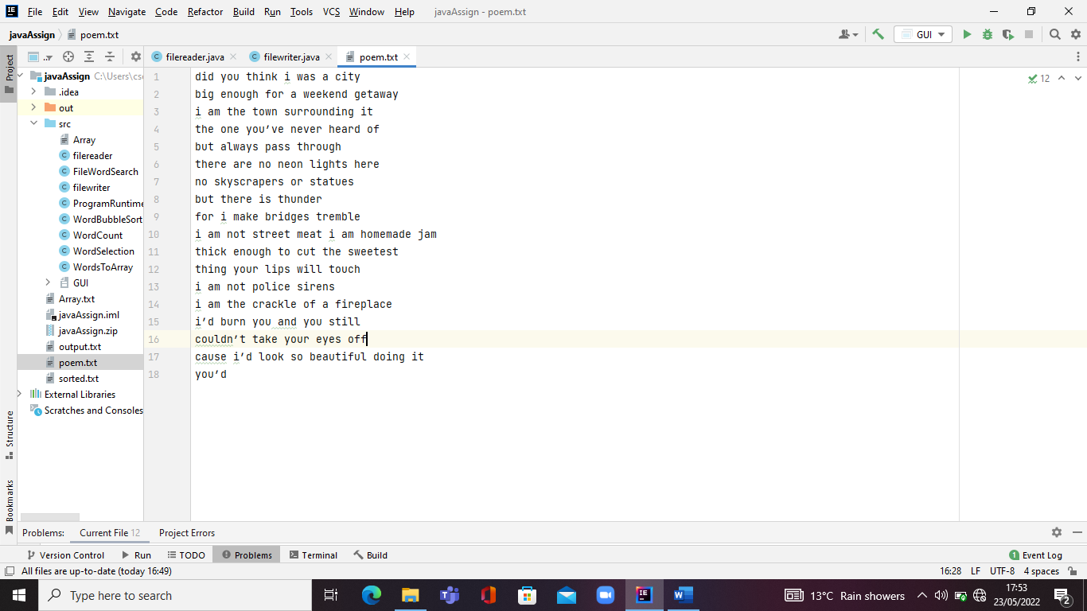

**2.FILE READER CLASS**

**The below picture shows a FILEREADER PROGRAM. The file reader program makes its possible for reading of the file along side with a class import (import java.io.Scanner;).**

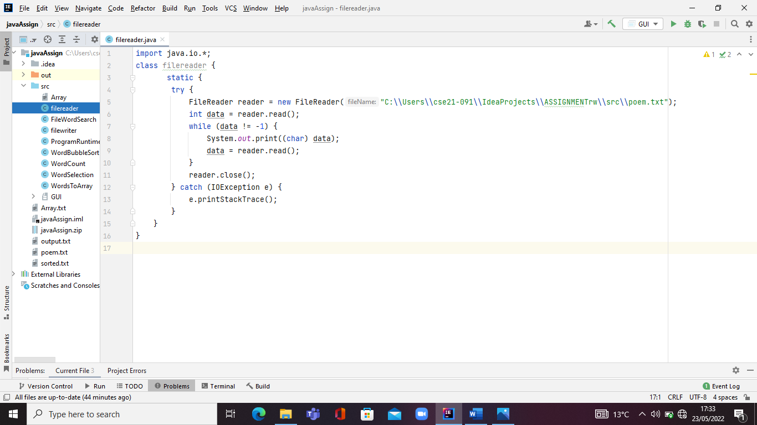

**3. FILE WRITER CLASS**

**The below picture shows a FILEWRITER CLASS. The file reader program makes its possible for the desired outputs to be written in a new set text file alongside with a few class imports .**

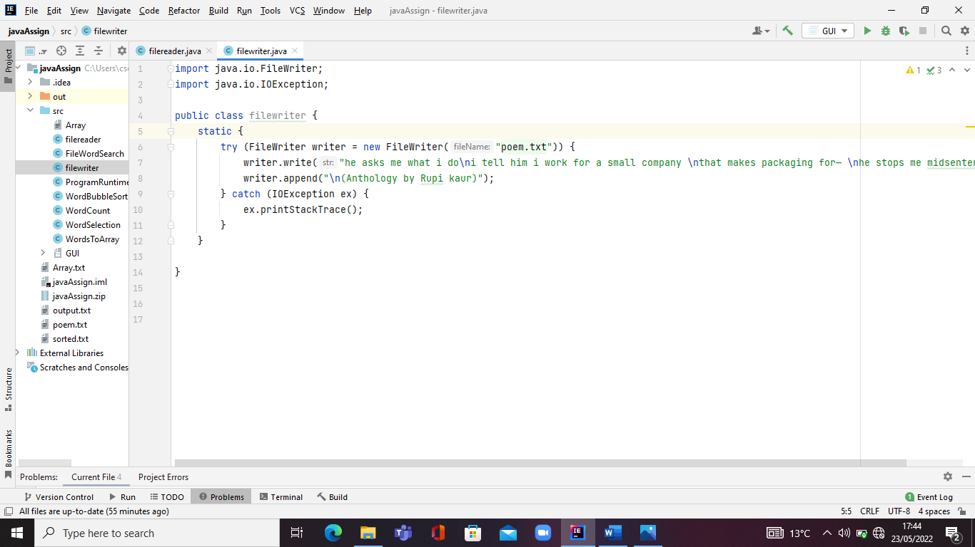

**4. WORD COUNTING CLASS**

**The below pictures show a WORD COUNTER BLOCK OF CODE. The counter program counts how many words are there in the text file and how many seconds it took for the counting to be executed before termination/end of the program alongside with a few class imports.**

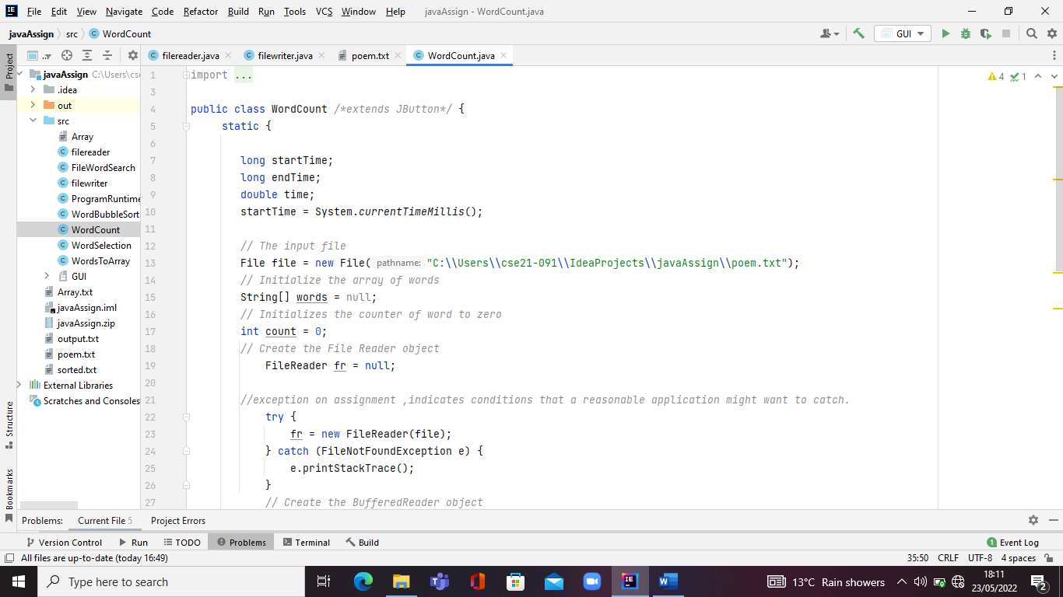

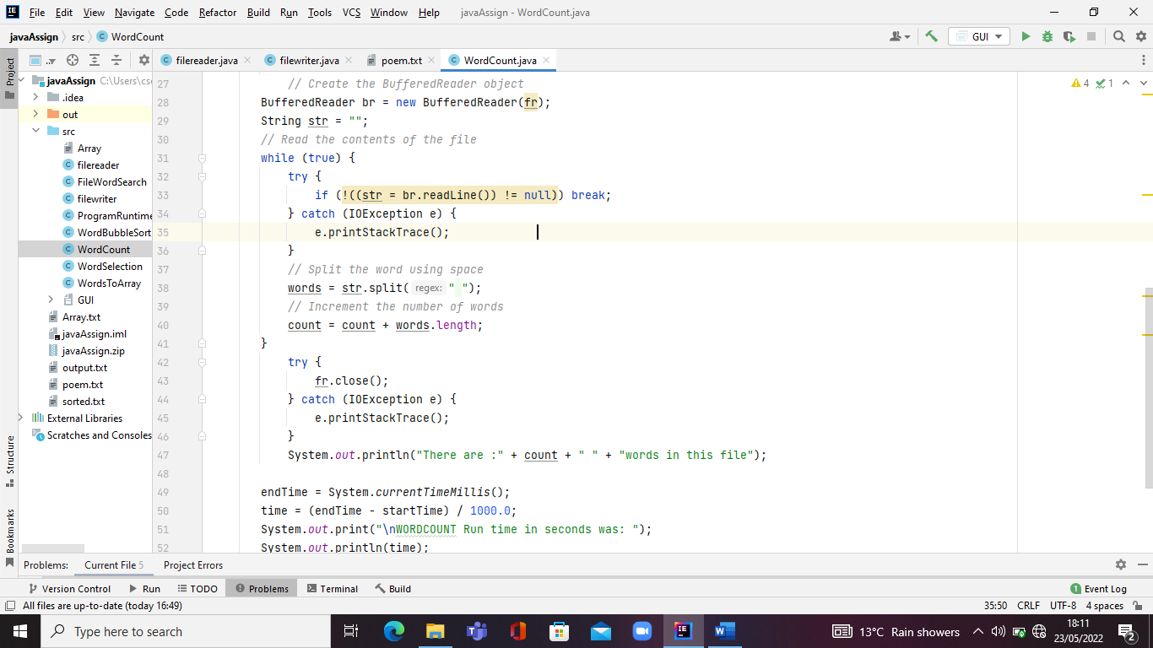

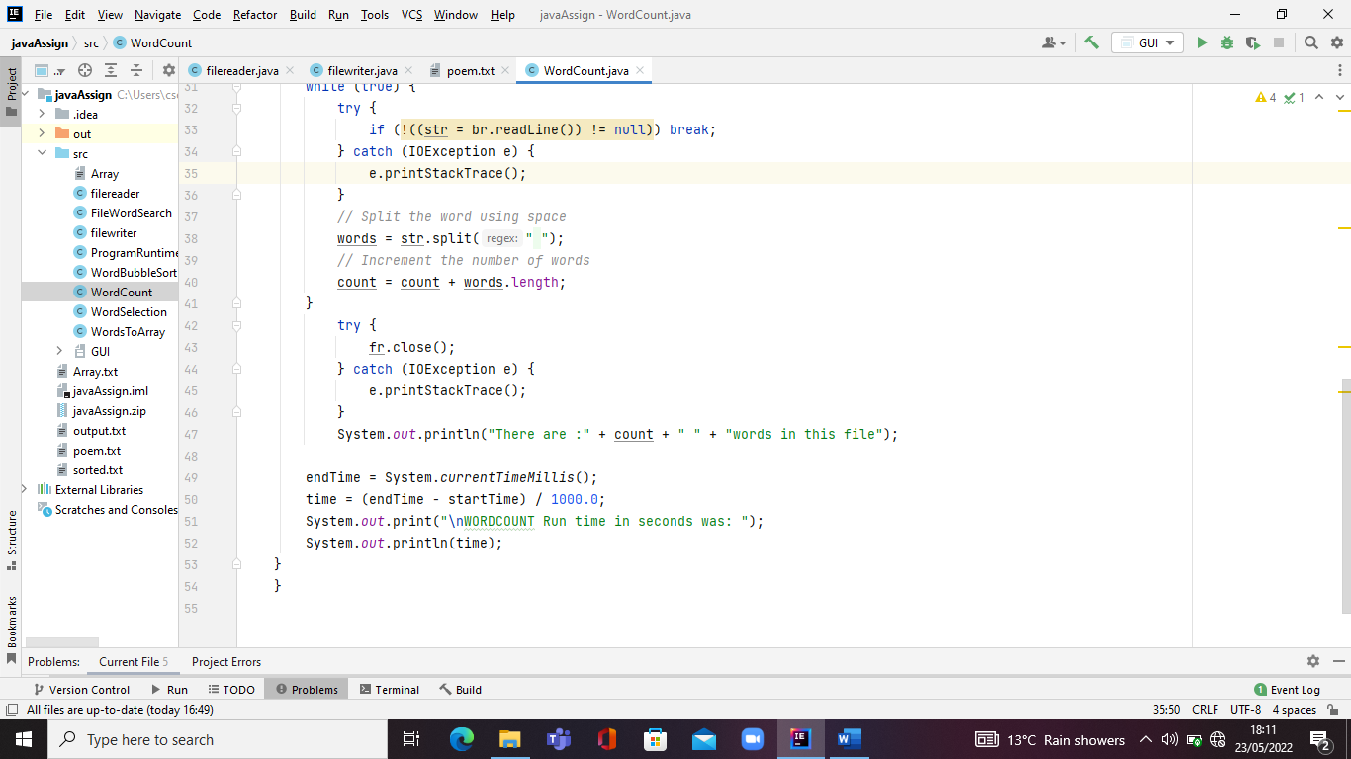

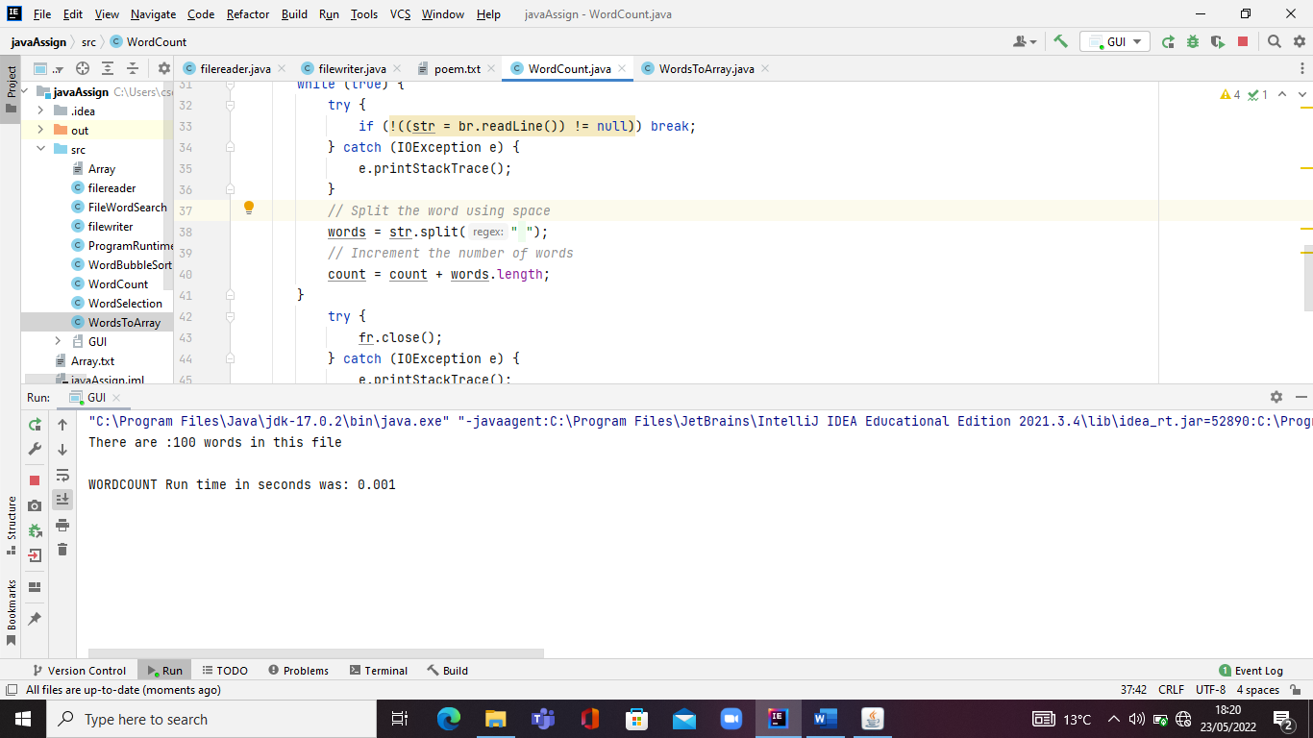

**4. WORDS TO ARRAY CLASS**

**The below pictures show a WORDS TO ARRAY CLASS. The word to array program converts words to array and adds the words to a new file alongside with a few class imports.**

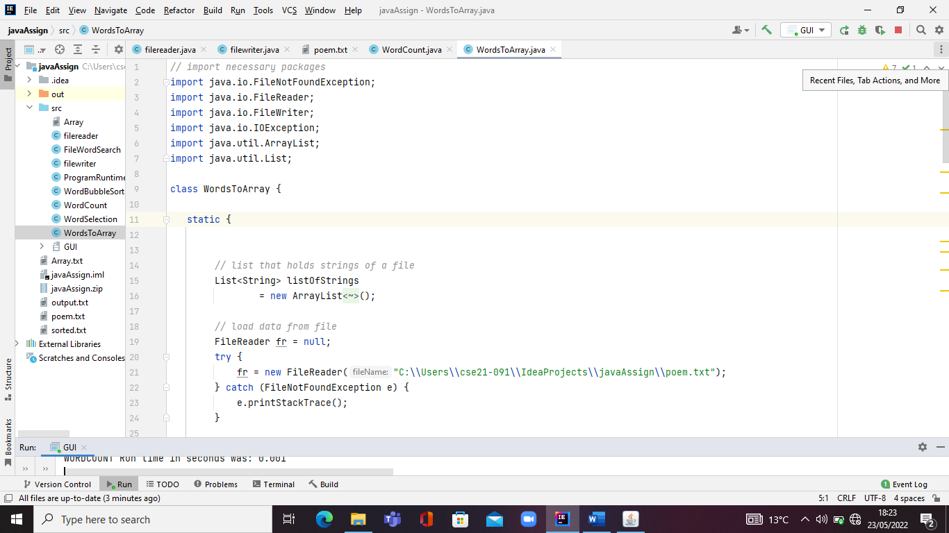

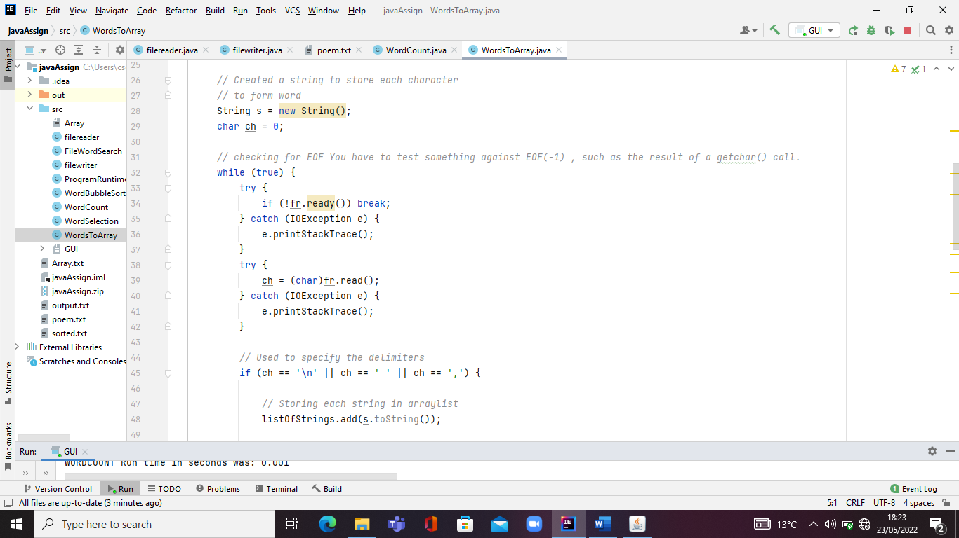

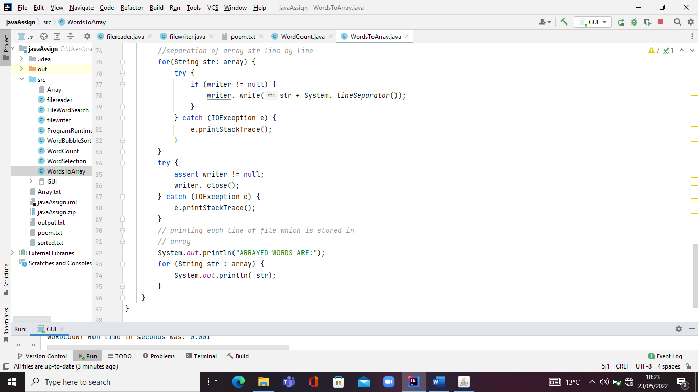

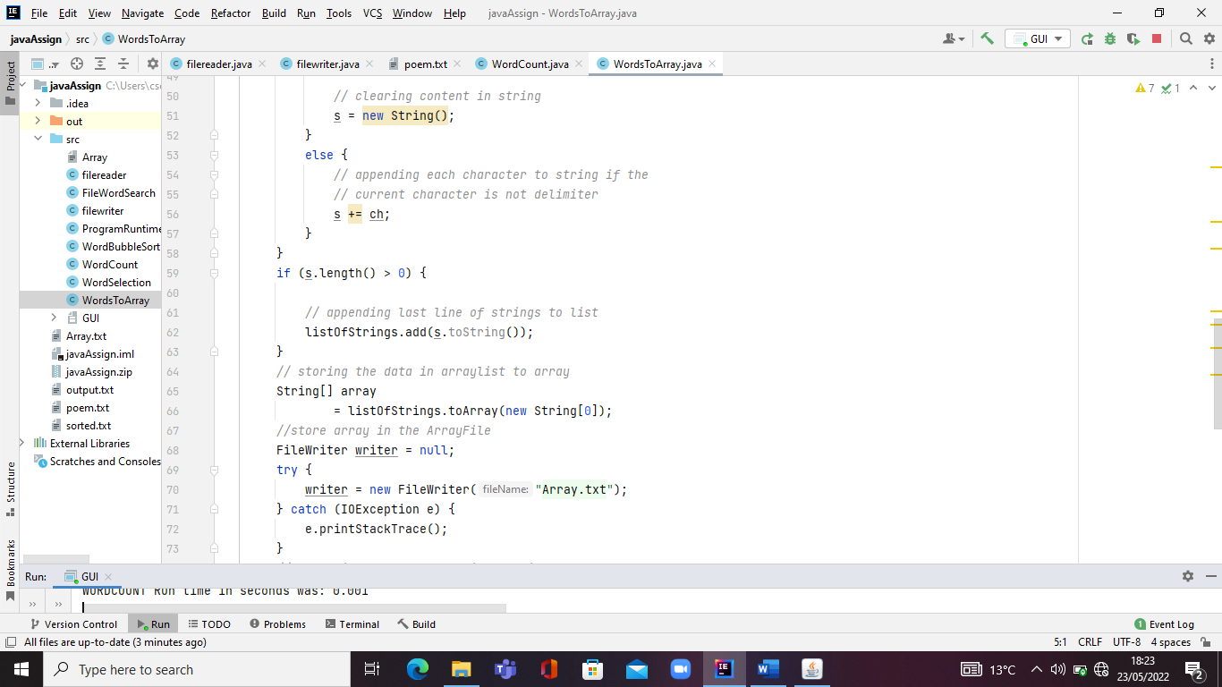

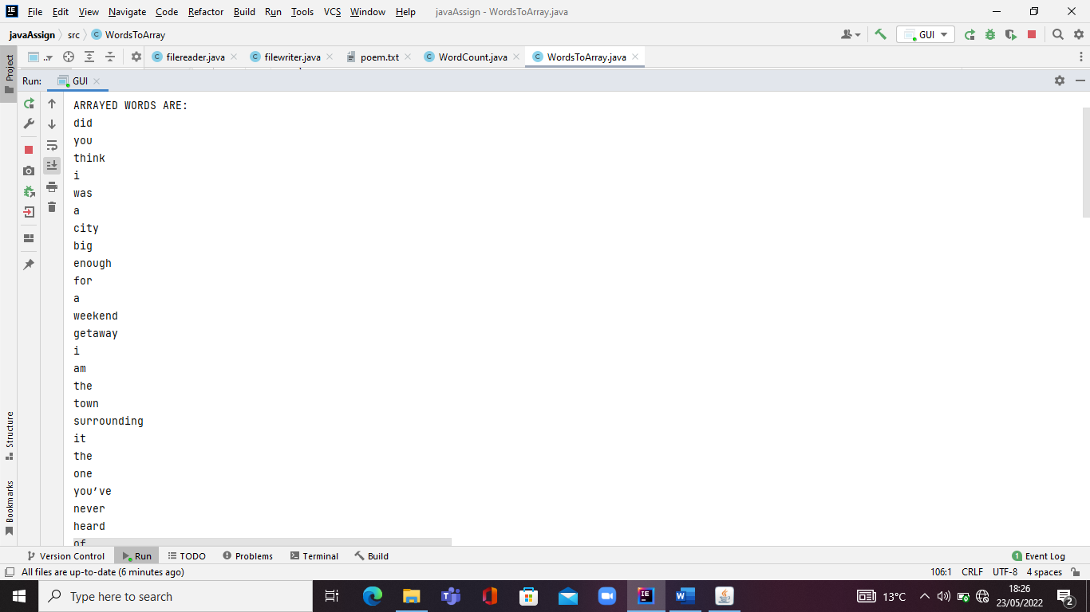

**5. WORD SELECTION CLASS**

**This class picks 20 words from any section of the file prints them out and write them into a new file along side with a few class imports.**

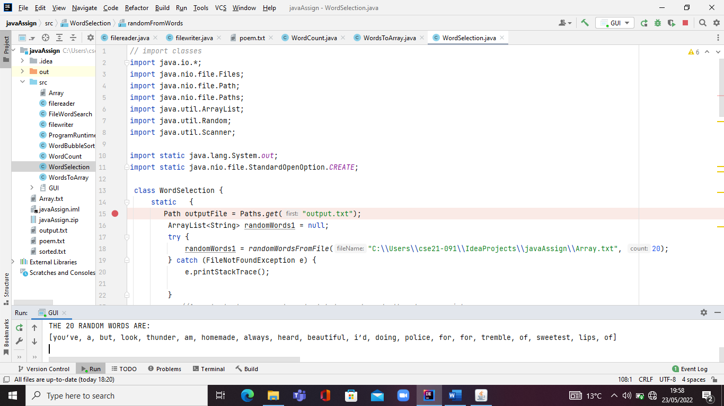

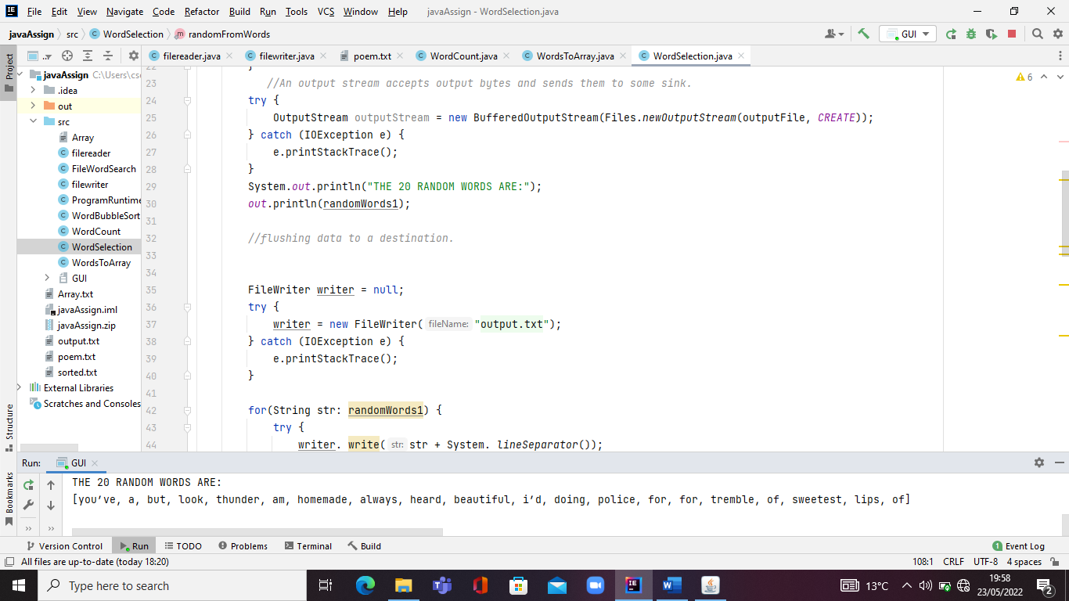

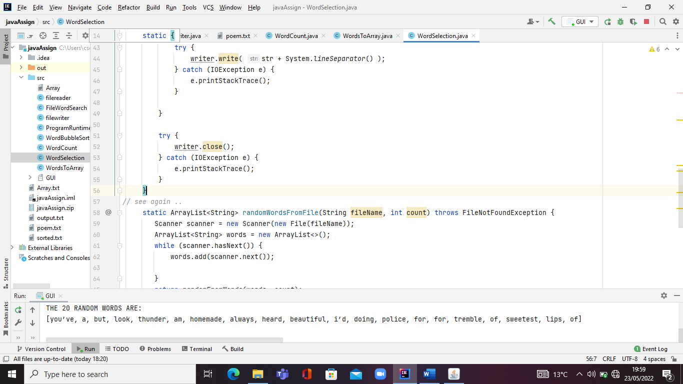

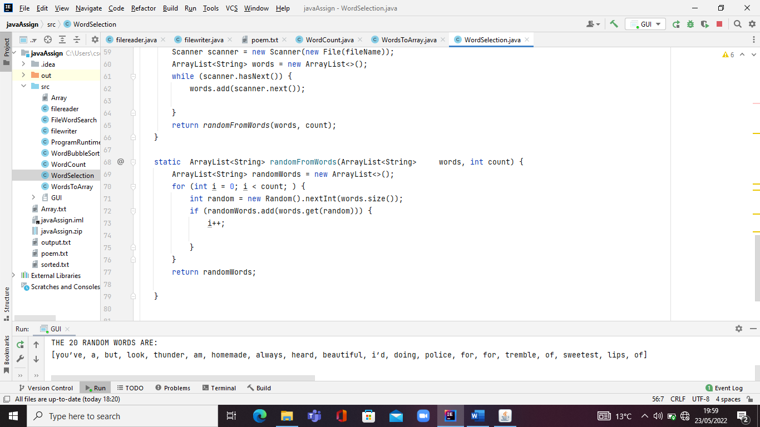

**6. WORD BUBBLE SORT CLASS**

**The below pictures show a WORD SORT CLASS. The word sort class program sorts word using BUBBLSORT ALGORITHM , adds the words to a new file after the sorting alongside with a few class imports and computes the runtime for the sorting to complete.**

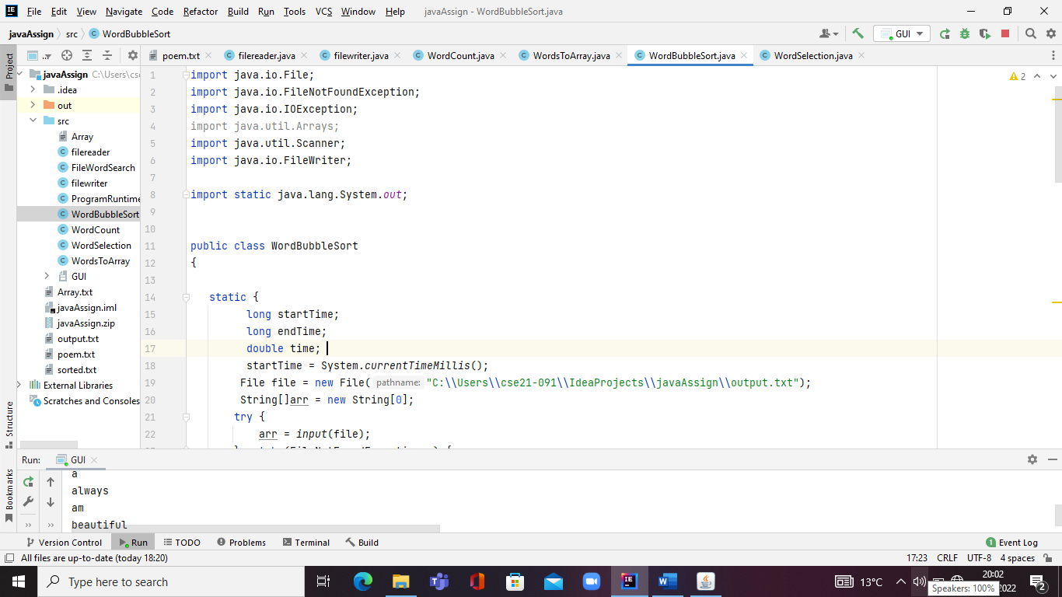

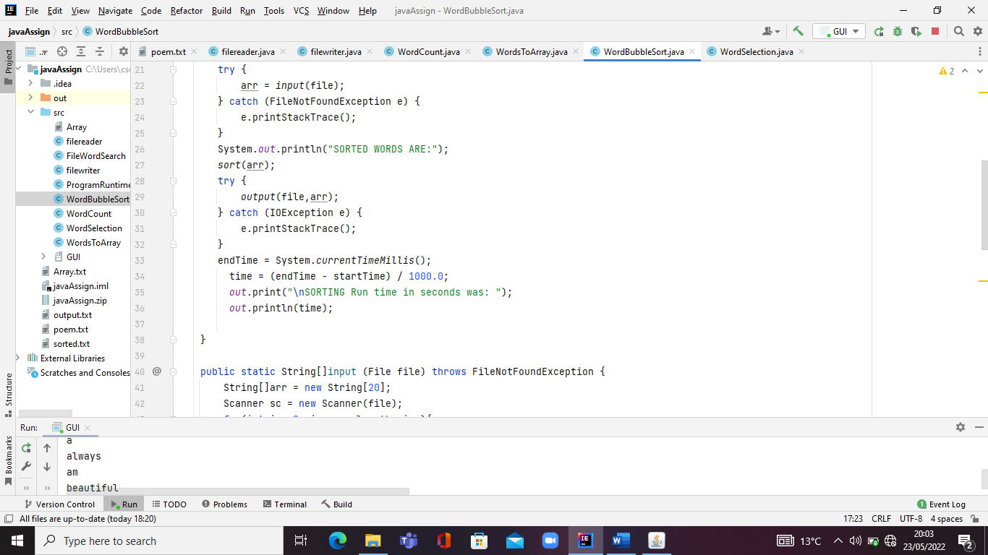

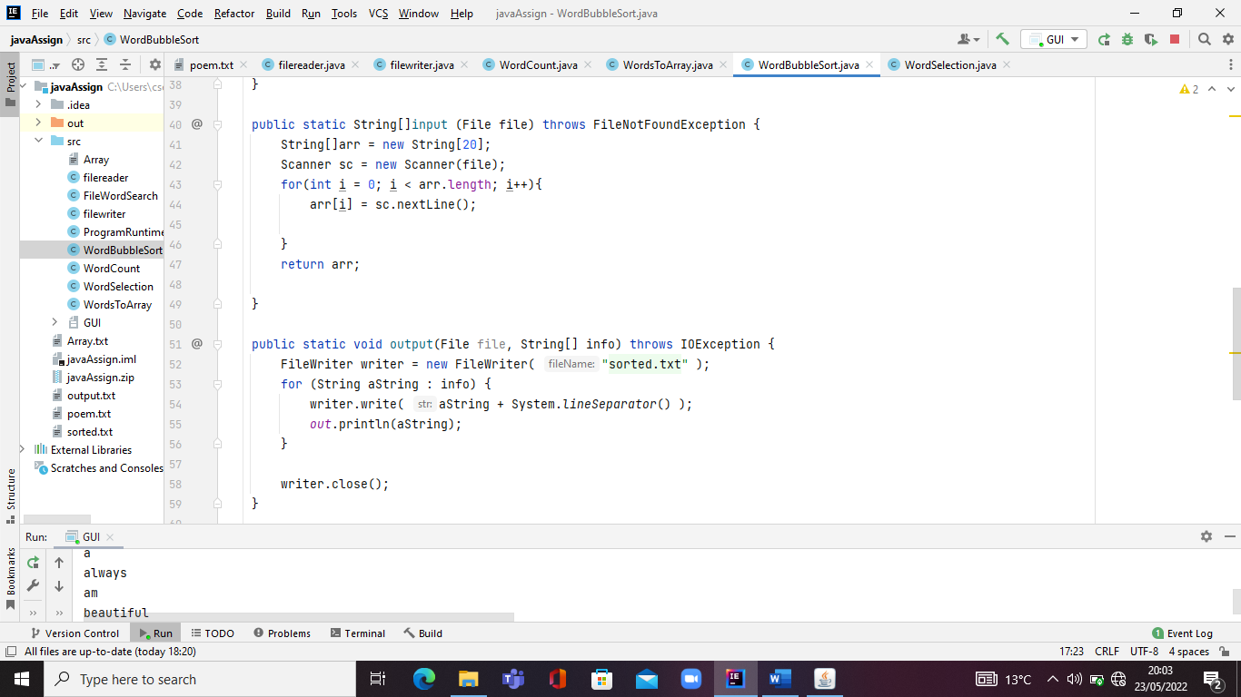

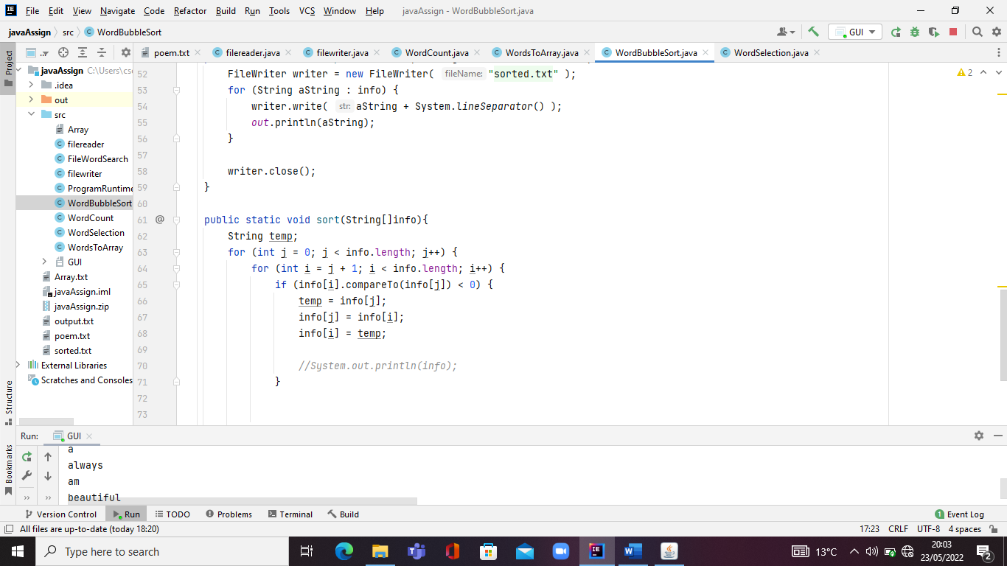

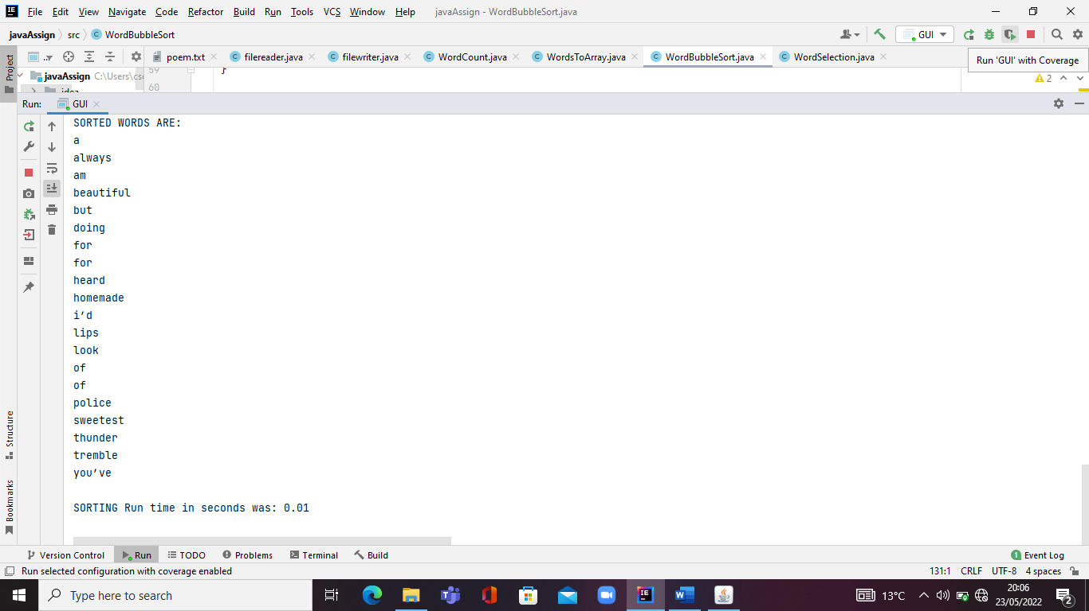

**6. FILE WORD SEARCH CLASS**

**The below pictures show a WORD SEARCH CLASS. The word search class work is done using A SCANNER and a alongside with a few class imports. The**

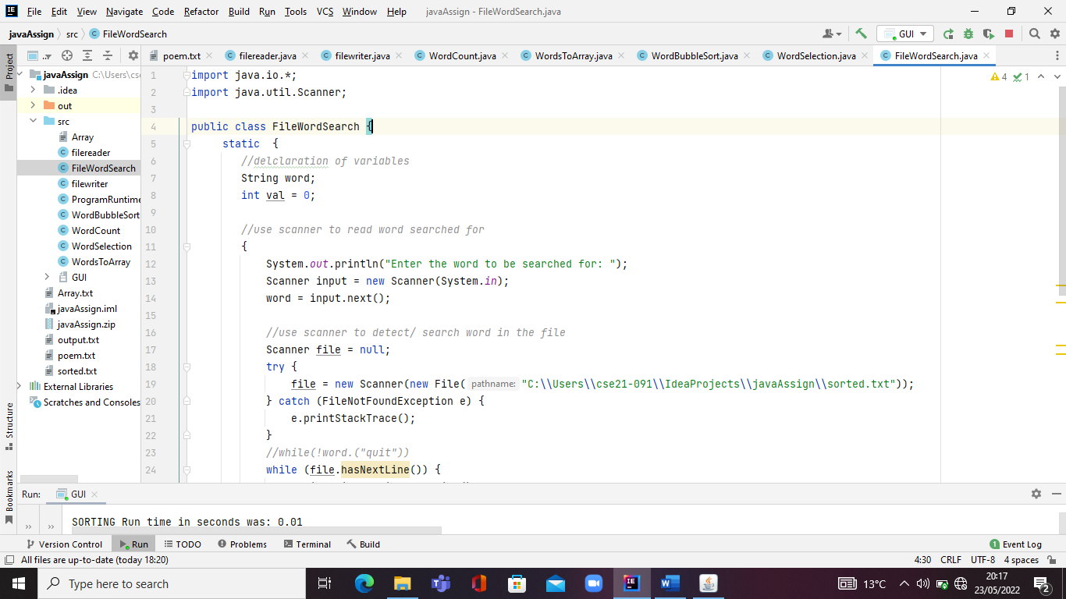

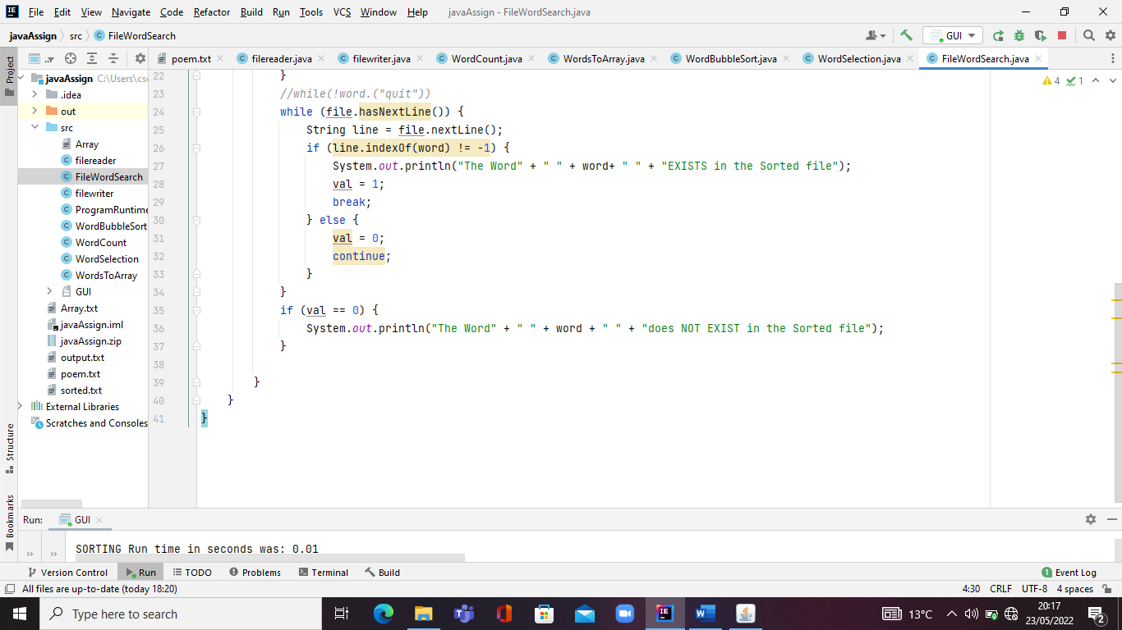

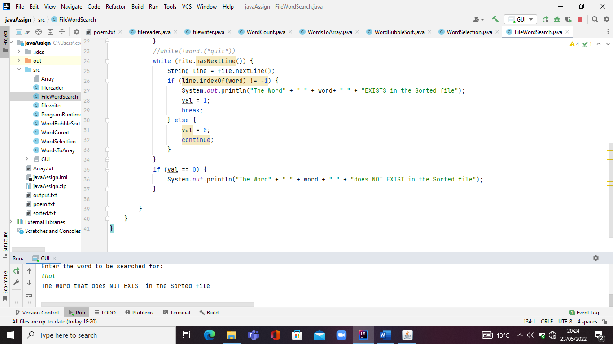

**7.GRAPHICAL USER INTERFACE**

**The program GUI consists of all the classes called into the GUI console through the addition of action listeners and action performed @override methods and Java swing at large.**

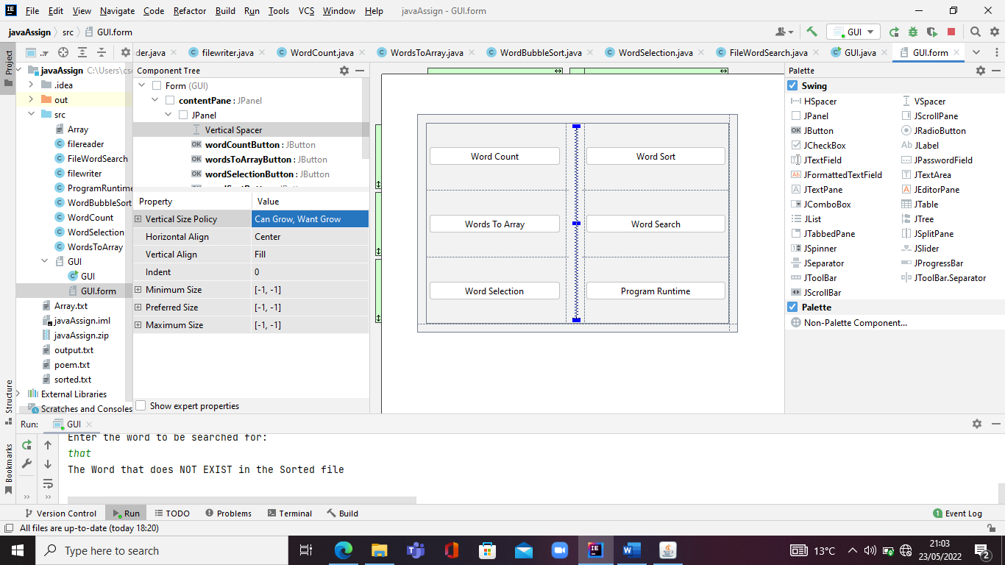

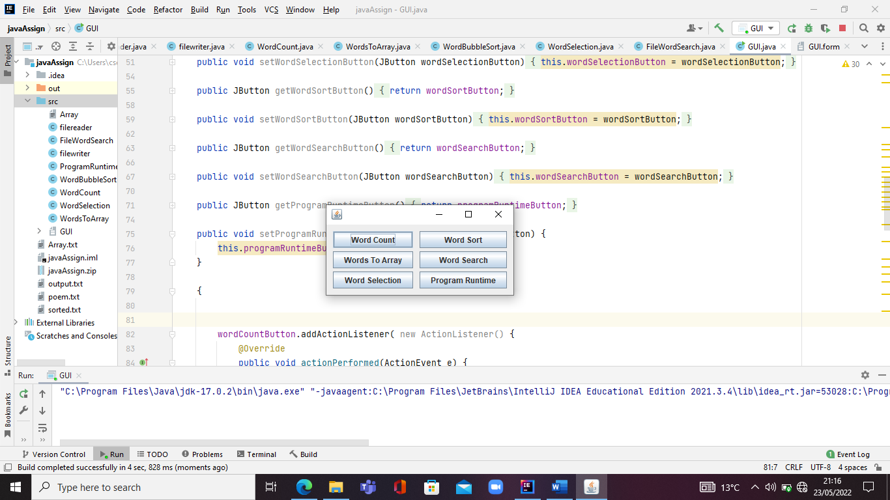

***WHAT HAVE I ACHIEVED?***

|  |  |
| --- | --- |
| ACHIEVEMENTS | NOT ACHIEVED |
| * A working GUI |  |
| * A readable File |  |
| * A working File Reading and writing class |  |
| * A working word counter class with Count runtime computations |  |
| * A working word to an array class with a new file that has and arrays List |  |
| * A working Word Sorter method with sort time and a new sorted file |  |
| * A working class that implements sorting algorithm |  |
| * A working search class that displays output |  |
| * A working word selector class that picks 20 words from the given readable file and flushes the data into a new file for the 20 words. |  |

***ADDITIONAL ACHIEVEMENTS:*** The entire GUI program runtime.

***FUTURE CODE MODOFICATIONS***

* A GUI with a text field area to display outputs upon method calls
* A GUI with a text field area to input words searched for and display search results after method call
* A GUI with set font, set boundaries and more color to it.
* A File deletion class
* A File format class

***TOOLS USED:***

* **IntelliJ Education**
* **JDK ORACLE 17**

***CONCLUSION:***

***The above screenshot shows code snaps their output and testcases.***